**Windows Command-Line Cheat Sheet**

To access the command line: start panel + search for cmd or in the keyboard hit the windows key 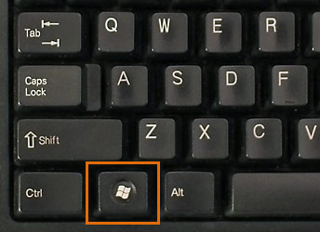+R

For help about any of the command just type help <name of command>

Files and Folders

1. cd/ go to root directory
2. cd <name of folder> or use chdir move through folders within your command prompt window.
3. cd .. exit current directory
4. dir view the files and folders within current directory
5. mkdir <directory name> create a new directory
6. dir <name of folder> get a list of everything in selected **sub-**directory
7. type <name of file> displays the contents of the file right within the command prompt window.
8. type <new text> > <name of file> replacing the whole content of the text in the file with the the new text
9. type <new text> >> <name of file> add content to the end of the file, instead of overwriting it
10. copy <file name to copy from> <file name to copy to> copy content from one file to another
11. del delete a file
12. move <file or folder name to be moved> <destination folder name> copy content from one file or directory to another
13. fc <switches> <path name one> <path name two> compare files to see if there are any content or binary code differences.

You can use the next switches with this command:

* /b – This switch will perform a binary comparison.
* /c – If you need to do a case insensitive comparison, use this switch.
* /a – This switch will make FC show only the first and last lines for each group of differences.
* /u – Use this switch to compare files as Unicode text files.
* /l – This will compare your files as ASCII text.
* /n – This switch can only be used with ASCII but it will show all the corresponding line numbers

General

1. ipconfig ip configuration
2. control opens the control panel
3. cls clear screen
4. tasklist gets the list of processes running on the system.
5. taskkill end a specific process
6. date display the date or change it

You can always find more commands on the Microsoft documentation site.

[Windows commands | Microsoft Docs](https://docs.microsoft.com/en-us/windows-server/administration/windows-commands/windows-commands)

And on [Useful CMD commands for daily use in Windows OS - GeeksforGeeks](https://www.geeksforgeeks.org/useful-cmd-commands-daily-use-windows-os/)